Paleis Bothmer en Feston-Laan

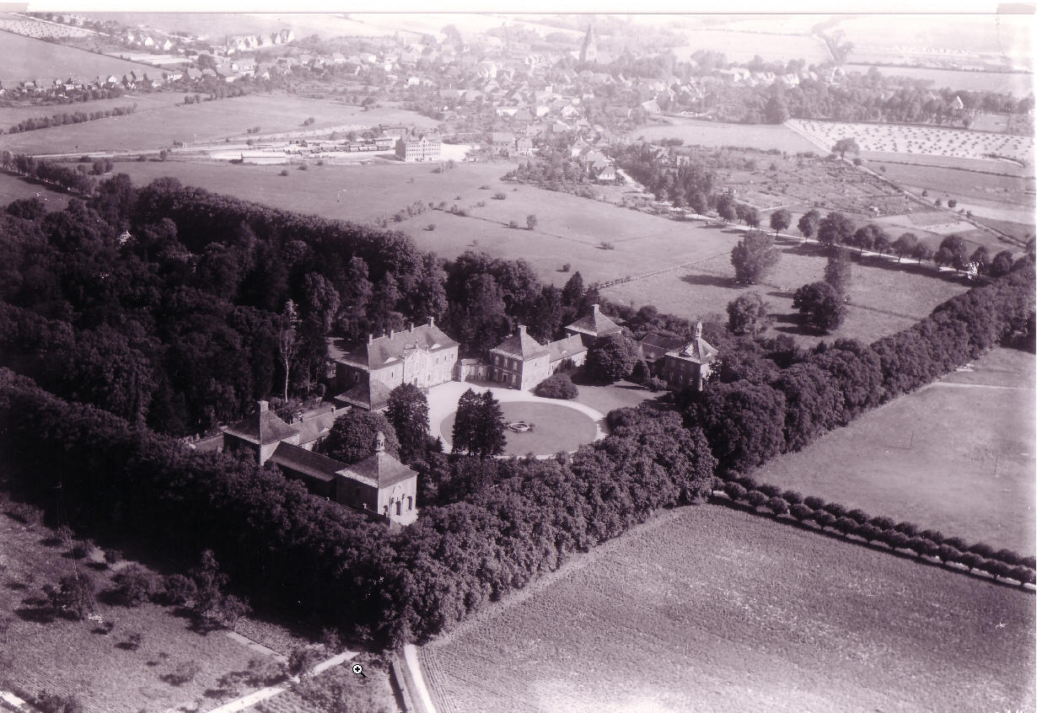

Who knows anything about these interesting lime-trees?

They build the so called “Feston-Avenue” at Castle Bothmer between the german cities
Luebeck and Wismar near the coast of the Baltic Sea. Castle Bothmer was built 1726-32 by Hans Caspar von Bothmer, who lived in the Netherlands for a couple of years. He was an important diplomat of the Hanoveranian House in the 17th and 18th century. It can be sure that he was associated with the court of William III and Mary in The Hague before he went to London for the rest of his life. Unfortunately he did not live to see the completion of castle Bothmer in 1732, that he built for his family. In his time in the Netherlands he might also have visited castles like “De Voorst” of Arnold Joost van Keppel “Het Loo” and others. The architecture of the buildings and the parc-structure also lead to traces in England and in the
Netherlands.

Nearly 500 lime-trees (Tilia x vulgaris) build one of the main structures of the parc, that is preserved until the present time. They are planted as avenues, together with a rectangular canal. The Feston-Avenue leads towards the castle on the mid axis in a length of about
270 m and contains of 69 lime-trees, that are cut every three years back to the stem. They build a kind of a double curving-line with a small way between the trees. Their tops touch each other in the line and leave an open gap between the lines. At one place the branches of two neighbouring trees have even been growed together.
Is this, what we see today, part of the original concept or is it a secondary result, that has occurred over a few hundred years? The trunks of some trees seem to be heavily divided in two parts, so that the left and right branches bow more and more down to the ground.
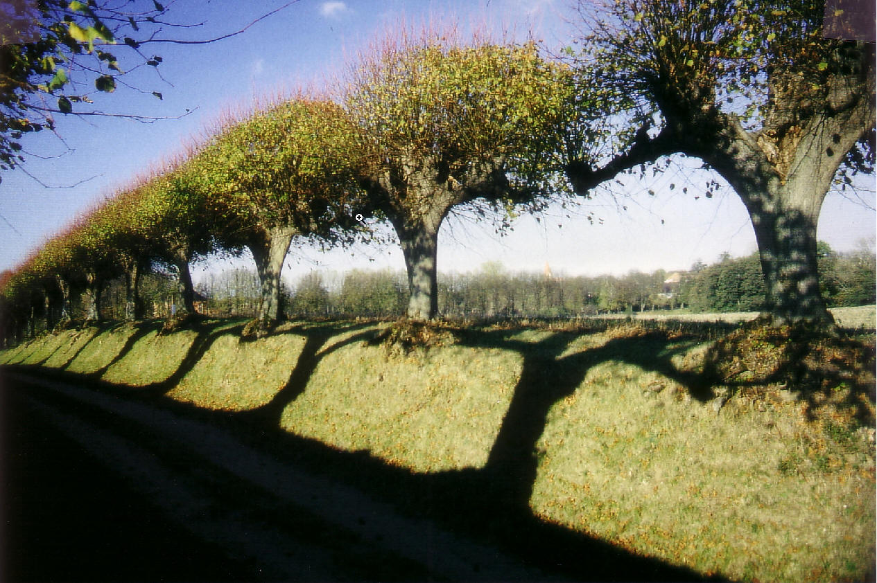

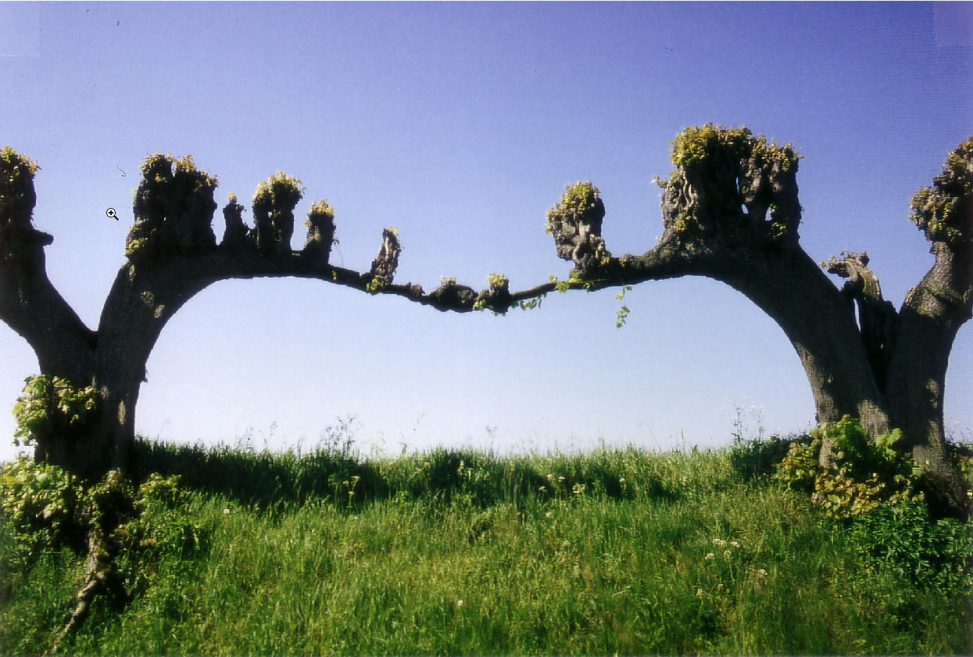

What might have been the desired effect of the artist and gardeners in the 18th century? It is obvious, that they wanted to create different effects with planting avenues. Not also the feston-avenue was cut periodically, but even the other seven avenues must have been treated by pruning. This is visible from old cutting-wounds on the trunks. It seems to be the purpose of growing to dark tunnels with shaded areas under the dense leaf. This helped to screen the castle and parc from the surrounding. In contrast to that the lime-trees of the feston-avenue are planted in a wider distance. And their tops are cut so that the sky and the landscape can be seen and the sun lightens the way through it.

One of the remaining questions is: How were the trees planted and pruned through the time of more than 250 years? – This is an important point for the future, because some trees are already lost and others begin to go down.
I have some ideas for a theory, but it can hardly be proved. Unfortunately there are no original references concerning the feston-avenue. During the Second World War important documents have been lost. So the only solution seems to draw conclusions from the trees theirselves, from their appearance and outer shape.

I’m still searching for similar examples of avenues, trees or tree-treatment in Europe.
I didn't find many until today. Does anyone on the forum have an idea? Do you know anyone else I can ask?

Possibly the feston-trees of Bothmer are the only ones left anywhere! If so, they should be regarded as a rare cultural treasure and in every way worth to be maintained or restored, if necessary and possible.

Geert Grigoleit
landscape-architect
Ahaus, Germany

